SMARTBAND V001
PCB Component & BOM Analysis Report
Band01_Rev1 — Hardware Procurement & Ordering Documentation

Prepared by: Masrur Jamil Prochchhod
Institution: Hochschule Hamm-Lippstadt (HSHL)
PCB Design Review & Component Procurement

1. Project Overview
This report documents the first task undertaken during the HSHL internship project involving the Smartband V001 (Band01_Rev1) — a wearable health monitoring device. The task predated any software or firmware development and focused entirely on understanding the hardware design, reviewing all PCB components, updating the Bill of Materials (BOM), communicating with PCB/component providers, and placing the manufacturing order.

The Smartband V001 is a compact wrist-worn device designed around the Texas Instruments CC2640R2F Bluetooth Low Energy (BLE) SoC. It integrates multiple biomedical sensors capable of measuring heart rate, blood oxygen saturation (SpO2), temperature, and motion, making it suitable as a research-grade wearable platform aligned with the Multi-sensor Wearable Health Device (MWHD) framework described by Pinheiro et al. (2022).

1.1 Design Files Received
The following design package was provided by the supervisor at project inception:
- Band01_Rev1.SchDoc — Altium Designer schematic source file
- Band01_Rev1.PcbDoc — Altium PCB layout source file
- Band01_Rev1.pdf — Exported schematic (colour, A4)
- Band01_Rev1_Mono.pdf — Exported schematic (monochrome)
- Band01_Rev1_3D.pdf — 3D PCB render
- BOM.pdf — Original Bill of Materials
- Fabrication Files/ — Gerber files, drill files for manufacturing

2. PCB Design Overview
The Band01_Rev1 PCB is a compact, two-layer board measuring 34 mm × 40 mm, designed for wrist-band form factor. The layout follows best-practice RF design principles for BLE operation, with a dedicated ground plane and impedance-controlled antenna trace.

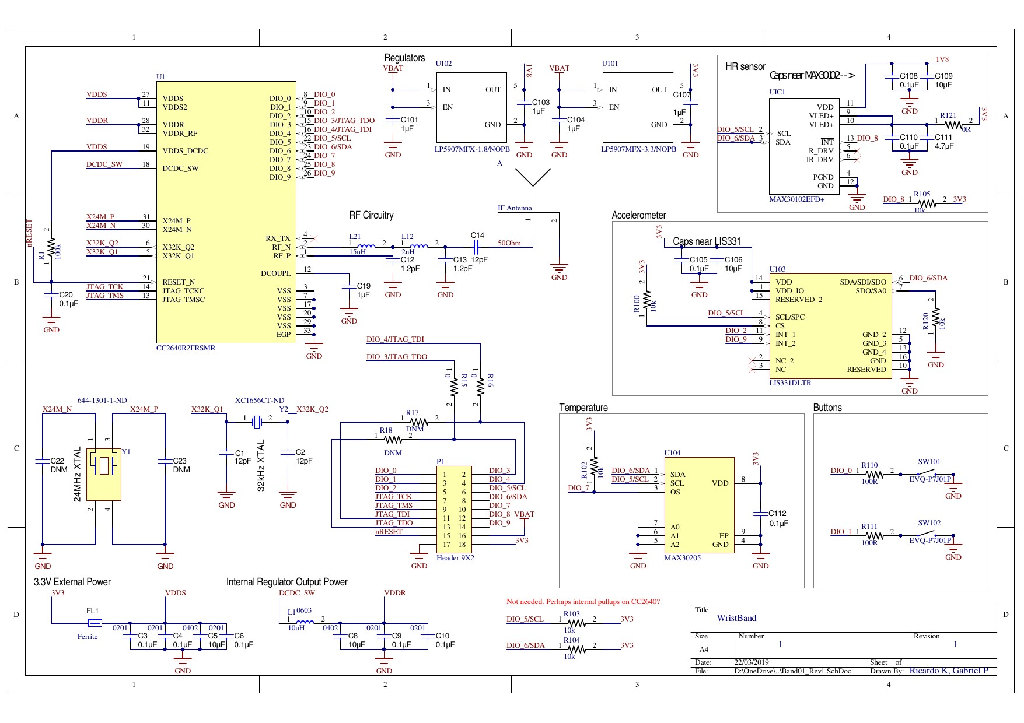
Figure 1: Band01_Rev1 Complete Circuit Schematic — Altium Designer Export

2.1 PCB Physical Specifications
Parameter | Value
Board Dimensions | 34 mm × 40 mm
Layer Count | 2-layer PCB
Via Specification | 0.2 mm hole / 0.3 mm copper
Trace Clearance | 0.15 mm minimum
Solder Mask Expansion | 0.05 mm
RF Antenna Impedance | 50 Ω controlled trace
Power Planes | VDDS (22.40 mm wide) + 3V3 (1.16 mm wide)
Antenna Design | PCB trace antenna per TI Application Note AN043 (SWRA117D)
Surface Finish | As per JLCPCB / Aisler specification

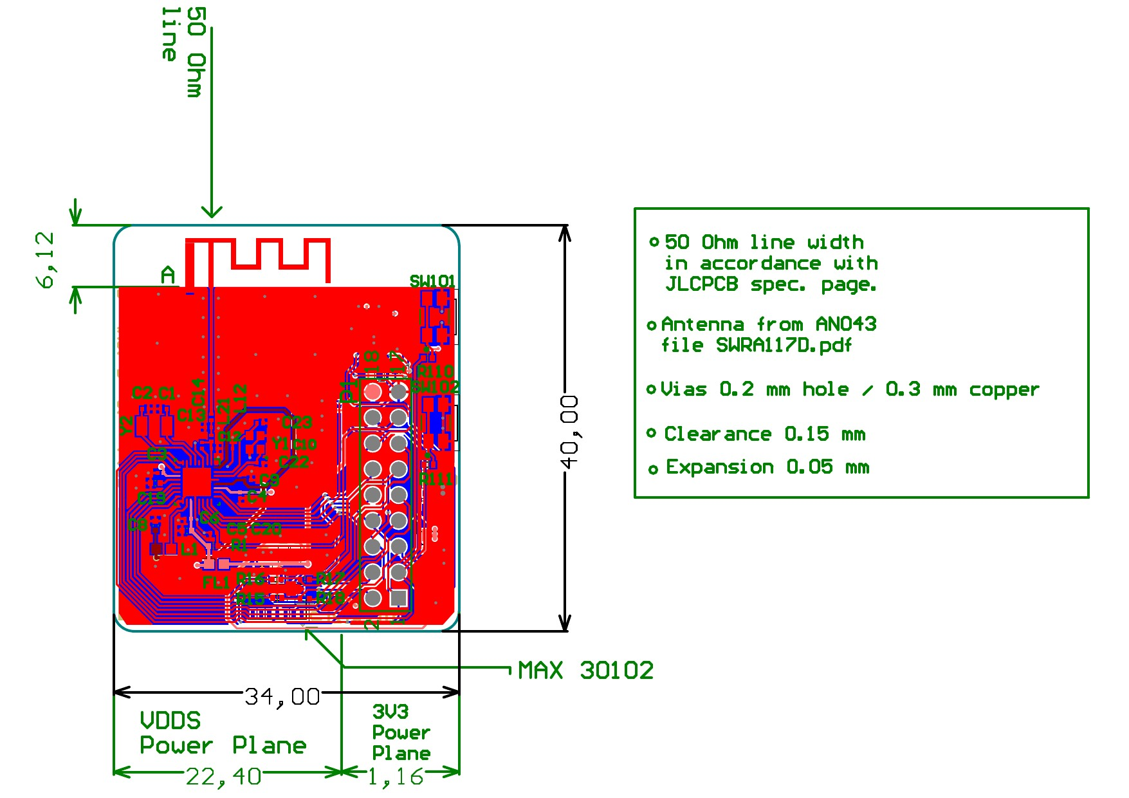
Figure 2: Band01_Rev1 PCB Layout with Power Planes and RF Antenna

2.2 Functional Subsystems
The schematic is organised into the following functional blocks:
- BLE SoC (U1 — CC2640R2FRSMR): Central microcontroller and wireless transceiver
- Power Regulation: Two LP5907MFX LDO regulators (U101: 3.3V, U102: 1.8V)
- RF Circuitry: Impedance-matching network (L21, L12, C12–C14) and PCB antenna
- HR & SpO2 Sensor (UIC1 — MAX30102): Optical heart-rate and blood oxygen sensor
- Accelerometer (U103 — LIS331DLTR): 3-axis MEMS accelerometer via I2C
- Temperature Sensor (U104 — MAX30205): Digital body temperature sensor
- Crystal Oscillators: 24 MHz (Y1) and 32.768 kHz (Y2)
- Debug Header (P1): 9×2 JTAG/SWD programming header
- User Buttons: SW101, SW102 — tactile push buttons

3. Original Bill of Materials
The original BOM was provided as part of the design package (BOM.pdf). It listed 29 line items covering all populated and DNP (Do Not Place) components across 33 individual designators. The document served as the starting point for procurement analysis.

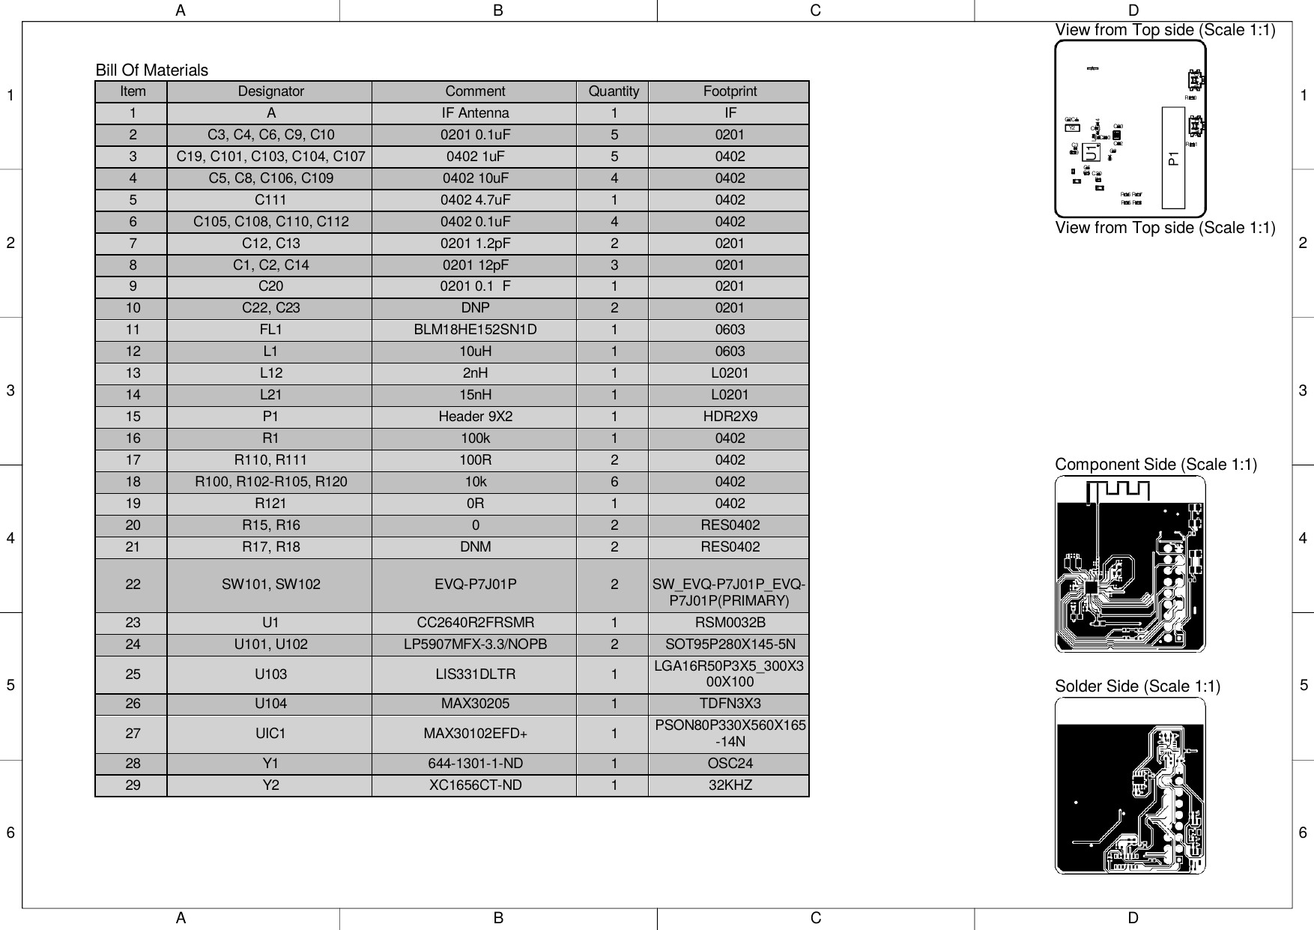
Figure 3: Original BOM as received — BOM.pdf from design package

3.1 Original BOM Summary
Category | Components | Count
Capacitors | C1–C14, C19–C23, C101–C112 | 28
Resistors | R1, R15–R18, R100–R105, R110–R111, R120–R121 | 14
Inductors / Ferrite | L1, L12, L21, FL1 | 4
ICs / SoC | U1, U101, U102, U103, U104, UIC1 | 6
Crystals / Oscillators | Y1, Y2 | 2
Connectors | P1 | 1
Switches | SW101, SW102 | 2
Antenna | A (IF_Antenna) | 1 (DNP)
DNP / DNM | C22, C23, R17, R18 | 4 items not placed

4. BOM Review & Analysis
A detailed review of each component was conducted against the schematic to verify correctness of part numbers, footprints, values, and availability. Key findings from the analysis:

4.1 Components Requiring Attention
Designator | Issue Identified | Action Taken
A (IF Antenna) | Listed but unassigned — PCB trace antenna used instead | Marked DNP in final BOM
C22, C23 | Marked DNP — optional bypass capacitors for 24 MHz crystal | Retained as DNP
R17, R18 | Marked DNM (Do Not Mount) — JTAG pull resistors not needed | Retained as DNM/DNP
P1 Header | Original BOM listed generic footprint; upgraded to Samtec HTSW-109-07-G-D | Part number updated
U104 (MAX30205) | Supplier listed as generic — sourced from ADI/Maxim (Analog Devices) | Supplier confirmed
UIC1 (MAX30102) | Price volatility flagged — PCBWay noted price subject to change | Price verified at order time
Y1 (24MHz) | Digikey part used in original; switched to muRata equivalent for availability | Substitution applied

5. Updated BOM — PCBWay Quotation
After completing the component review and resolving availability issues, an updated BOM was submitted to PCBWay for assembly quotation (Product No.: T-2Y3W994845A). The quotation covered 3 assembled PCB sets.

5.1 Complete Updated BOM
# | Designator | Value/Part | Qty | Manufacturer | MPN | Unit Price
1 | A | IF Antenna | 1 | — | — | DNP
2 | C1, C2 | 12pF | 2 | muRata | GRM0335C1H120JA01D | €0.023
3 | C3,C4,C6,C9,C10 | 0.1µF (0201) | 5 | muRata | GRM033C80J104KE15D | €0.009
4 | C5,C8,C106,C109 | 10µF (0402) | 4 | muRata | GRM155C80J106ME11D | €0.14
5 | C12, C13 | 1.2pF | 2 | Kyocera AVX | 02013A1R2BAT2A | €0.686
6 | C14 | 12pF | 1 | muRata | GRM0335C1E120JA01D | €0.067
7 | C19,C101,C103,C104,C107 | 1µF (0402) | 5 | Samsung | CL05A105MQ5NNNC | €0.005
8 | C20 | 0.1µF (0201) | 1 | muRata | GRM033C80J104KE15D | €0.037
9 | C22, C23 | DNP (0201) | 0 | muRata | GRM0335C1H120JA01D | DNP
10 | C105 | 0.1µF (0402) | 1 | KEMET | C0402C104M9PACTU | €0.564
11 | C108, C110 | 0.1µF (0402) | 2 | KEMET | C0402C104M9PACTU | €0.319
12 | C111 | 4.7µF (0402) | 1 | muRata | GRM155R60J475ME47D | €0.063
13 | C112 | 0.1µF (0402) | 1 | KEMET | C0402C104M9PACTU | €0.564
14 | FL1 | Ferrite Bead | 1 | muRata | BLM18HE152SN1D | €0.278
15 | L1 | 10µH (0603) | 1 | Taiyo Yuden | LBMF1608T100K | €0.364
16 | L12 | 2nH (0201) | 1 | muRata | LQP03TN2N0B02D | €0.036
17 | L21 | 15nH (0201) | 1 | muRata | LQP03TN15NH02D | €0.077
18 | P1 | Header 9×2 | 1 | CST | CS-1106-2X9 (L10.0) | €2.214
19 | R1 | 100kΩ | 1 | Yageo | RC0402JR-10100KL | €0.048
20 | R15, R16 | 0Ω (jumper) | 2 | Yageo | RC0402JR-070RL | €0.003
21 | R17, R18 | DNM | 0 | Yageo | RC0402JR-070RL | DNP
22 | R100–R105, R120 | 10kΩ | 6 | Yageo | SY0402DD10KP | €0.049
23 | R110, R111 | 100Ω | 2 | Vishay | CRCW0402100RJNED | €0.20
24 | R121 | 0Ω | 1 | Yageo | RC0402JR-070RL | €0.006
25 | SW101, SW102 | Tactile Switch | 2 | Panasonic | EVQ-P7J01P | €0.512
26 | U1 | BLE SoC | 1 | TI | CC2640R2FRSMR | €2.013
27 | U101 | LDO 3.3V | 1 | TI | LP5907MFX-3.3/NOPB | €0.255
28 | U102 | LDO 1.8V | 1 | TI | LP5907MFX-1.8/NOPB | €0.284
29 | U103 | Accelerometer | 1 | ST | LIS331DLTR | €2.013
30 | U104 | Temp Sensor | 1 | ADI/Maxim | MAX30205MTA+T | €8.278
31 | UIC1 | HR/SpO2 Sensor | 1 | ADI/Maxim | MAX30102EFD+ | €15.094
32 | Y1 | 24MHz Crystal | 1 | muRata | XRCGB24M000F1H17R0 | €0.752
33 | Y2 | 32kHz Crystal | 1 | ECS | ECS-.327-7-34B-TR | €1.361

5.2 PCBWay Cost Breakdown — 3 Sets
Cost Item | Amount (USD)
Component Cost | $116.33
Assembly Cost | $88.00
PCB Fabrication Cost | $25.97
Discount (V0 Member) | $0.00
Total — 3 Sets | $230.30
Unit Cost per Board | ≈ $76.77
Lead Time | 26–28 working days

6. Aisler BOM — Final Assembled PCB
In parallel with the PCBWay process, the project was also registered on the Aisler platform (Hochschule Hamm-Lippstadt workspace) under project Band01_Rev1 (ULZXZIGI). Aisler provides an integrated component assignment workflow with real-time stock and pricing from supported distributors. The Aisler BOM represents the final component assignment state used for the assembled PCB order.

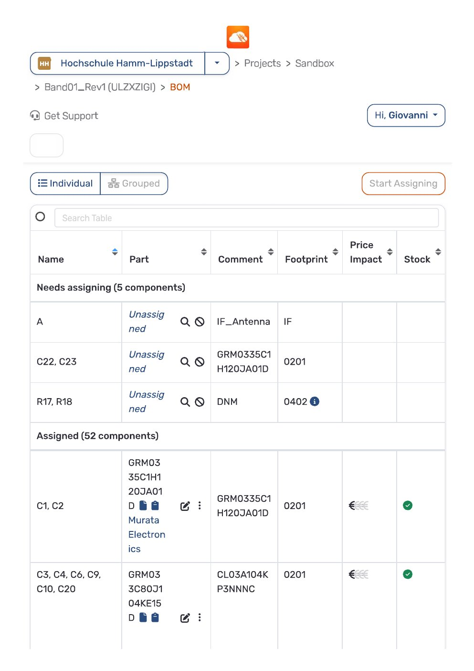
Figure 4: Aisler BOM — Component assignment view, Page 1

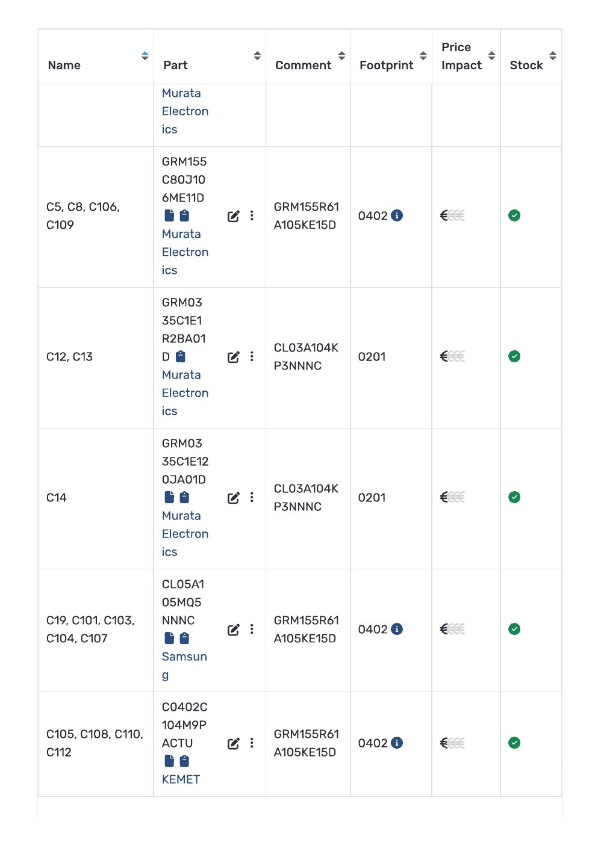
Figure 5: Aisler BOM — Component assignment view, Page 2

6.1 Aisler Component Status
Status | Count | Notes
Assigned (in stock) | 52 components | All sourced from supported distributors
Needs Assigning | 5 components | A (DNP), C22/C23, R17/R18
DNP (Do Not Place) | 4 items | Antenna, optional caps, unused resistors
Total Unique Items | 57 items | Including DNP entries

6.2 Aisler Pricing Tiers
Quantity | Total Price | Unit Price / Board
3 sets | €376.69 | €125.56
5 sets | €439.65 | €87.93
10 sets | €590.66 | €59.07
50 sets | €1,893.43 | €37.87
100 sets | €3,249.84 | €32.50
200 sets | €6,183.19 | €30.92
500 sets | €14,134.49 | €28.27
Note: Prices are best-price net-prices from supported distributors including sourcing expenses and handling fees. Valid for 24 hours from quotation.

7. Key Component Highlights
The following section highlights the most technically significant components on the board and their roles in the wearable health monitoring application.

Component | Part Number | Function | Interface
CC2640R2FRSMR (U1) | TI CC2640R2F | BLE 5.0 SoC — ARM Cortex-M3 @ 48 MHz, 128KB Flash, 20KB RAM | JTAG / SWD
MAX30102EFD+ (UIC1) | Maxim MAX30102 | Heart Rate & SpO2 optical sensor — integrated LED driver, 18-bit ADC | I2C
LIS331DLTR (U103) | ST LIS331D | 3-axis ±24g accelerometer — motion/activity detection | I2C
MAX30205MTA+T (U104) | Maxim MAX30205 | ±0.1°C accurate body temperature sensor | I2C
LP5907MFX-3.3 (U101) | TI LP5907 | Ultra-low noise 3.3V LDO regulator — powers CC2640R2F and peripherals | —
LP5907MFX-1.8 (U102) | TI LP5907 | Ultra-low noise 1.8V LDO regulator — powers HR sensor | —

8. Procurement Process & Provider Communication

8.1 Process Summary
The procurement process followed these sequential steps:
- Step 1: Received design ZIP package from supervisor (giovannix) via private GitHub repository
- Step 2: Reviewed schematic (Band01_Rev1.pdf) and extracted all component information
- Step 3: Cross-referenced original BOM.pdf against schematic to identify gaps and errors
- Step 4: Researched component availability on Mouser, DigiKey, LCSC, and Aisler
- Step 5: Resolved 5 components requiring action (see Section 4.1)
- Step 6: Prepared updated BOM in PCBWay format for assembly quotation
- Step 7: Submitted BOM to PCBWay — received quote for 3 sets at $230.30 total
- Step 8: Registered project on Aisler platform under HSHL workspace
- Step 9: Assigned all available components in Aisler (52/57 assigned)
- Step 10: Confirmed order placement for PCB fabrication and assembly

8.2 Provider Summary
Provider | Role | Platform | Outcome
PCBWay | PCB fabrication + assembly | pcbway.com | Quotation received — $230.30 / 3 sets, 26–28 day lead time
Aisler | PCB fabrication + assembly (EU) | aisler.net | Component assignment complete, €376.69 / 3 sets
Mouser Electronics | Component sourcing | mouser.com | Used for availability cross-check
DigiKey | Component sourcing | digikey.com | Y1 crystal original part source
LCSC | Component sourcing | lcsc.com | Used for KEMET capacitor pricing

9. Conclusion & Next Steps
This phase of the project successfully delivered a complete hardware understanding of the Smartband V001 PCB, a corrected and validated Bill of Materials, provider communications, and a confirmed manufacturing order through both PCBWay and Aisler platforms.

The board was ordered in quantities of 3 sets to allow for prototyping, testing, and potential rework. Upon delivery, the hardware will be prepared for firmware flashing using Texas Instruments Code Composer Studio (CCS) targeting the CC2640R2F BLE SoC.

Immediate Next Steps
- Await PCB delivery from PCBWay / Aisler (26–28 day lead time)
- Visual and electrical inspection of assembled boards upon receipt
- Set up Code Composer Studio (CCS) environment for CC2640R2F
- Flash and validate firmware build — proceed to Task 2 (Firmware Analysis)
- Begin sensor integration and BLE data transmission testing

